3GPP TSG RAN WG1 #125 R1-2604429
Dalian, China, May. 18th ~ 22nd, 2026

Agenda Item: 10.8.3
Source: Quectel
Title: Discussion on waveform for 6G ISAC
Document for: Discussion

1.Introduction
In this contribution, we propose waveform design for sensing, based on the integration of spread spectrum techniques into existing OFDM-based waveforms. With CP-OFDM, the integration is expected to simultaneously improve communication performance e.g. robustness to deep fading and PAPR, and sensing resolution in ISAC scenario. The design of waveforms to meet coverage requirements of 6GR is investigated for downlink.

2. Waveforms for 6GR via Spread Spectrum

2.1 Impact of spread spectrum to communication and sensing
In the development of 6G communication systems, the introduction of new physical-layer waveform candidates is essential. As a fundamental component of the physical layer, the waveform directly impacts signal coverage. In future 6G scenarios, signals are expected to operate at significantly higher carrier frequencies than in 5G. Moreover, with the increasing prevalence of non-terrestrial networks (NTN), signals are often required to be transmitted over much longer distances. Those poses substantial challenges to coverage. Consequently, the design of waveforms that can effectively meet coverage requirements under high-frequency and long-distance transmission conditions is a critical issue and is investigated in this work.
As the coverage range increases, a lower PAPR is required to ensure efficient power amplification and reliable signal transmission. In long-range communication scenarios, the transmit power is typically constrained by hardware limitations and regulatory requirements, making power amplifier (PA) efficiency a critical factor. High-PAPR waveforms force the PA to operate with significant output back-off to avoid nonlinear distortion, which substantially reduces the average transmit power and degrades coverage performance. By contrast, waveforms with lower PAPR enable more efficient PA operation, allowing higher average transmit power for a given peak power constraint, thereby improving link budget and extending coverage.
Increasing the occupied bandwidth enhances phase diversity among frequency components and shortens the coherent superposition interval of cross terms in the time domain, thereby reducing the probability of extreme peaks and lowering the PAPR. From a signal representation perspective, larger frequency spacing increases the temporal variation rate of the phase differences between spectral components, causing the cross terms in the instantaneous power expression to decorrelate more rapidly. Consequently, the duration over which constructive superposition occurs is reduced, leading to a lower probability of extreme instantaneous power values and, hence, a reduced PAPR.
Spectrum extension has the potential to reduce PAPR by increasing the number of available frequency components and thereby enhancing phase diversity across the signal. When more frequency components are utilized, the likelihood that multiple components align coherently at the same time decreases, which reduces the probability of extreme peaks in the time-domain waveform. Building on this principle, applying spectrum extension more extensively—such as allocating additional subcarriers or widening the occupied bandwidth—can further enhance this effect, leading to even lower PAPR. In addition, a lower PAPR allows the power amplifier to operate more efficiently, increasing the average transmit power without violating peak power constraints, which is particularly beneficial for coverage in high-frequency and long-range communication scenarios.
Proposal 1: Spectrum extension has the capability to reduce PAPR. Building upon this foundation, the expanded scope of spectrum extension application can be considered for reducing PAPR.
Furthermore, it is proposed to further investigate the performance of spectrum extension specifically for sensing applications. Larger spectrum extension parameters can enhance sensing performance. The increased bandwidth provides:
- Improved range resolution due to wider signal bandwidth
- Better signal-to-noise ratio in sensing operations
- Increased accuracy in target detection and parameter estimation
Proposal 2: Extending the waveform to enable controlled spectrum spreading should be considered, with the option of overlapping resources among multiple users. In addition, alternative spectrum extension schemes beyond the currently defined extension factors should be explored. Such approaches can enhance sensing resolution while maintaining low PAPR and preserving coverage performance.
Due to increasing interference from various wireless devices, certain frequency bands may experience unexpected deep fading, which can lead to communication outages for users assigned to those bands. By employing spectrum spreading, frequency diversity can be achieved, providing notable benefits from both communication and sensing perspectives. From a communication standpoint, spectrum extension offers frequency diversity gains and reduces PAPR, improving signal reliability and coverage. From a sensing perspective, it enables wider signal bandwidth, which leads to enhanced range resolution, improved SNR in sensing operations, and increased accuracy in target detection and parameter estimation.
Spectrum extension inevitably leads to a reduction in spectral efficiency due to the increased occupied bandwidth relative to the transmitted information rate. However, this loss in spectral efficiency can be effectively mitigated through coordination among multiple users. By enabling controlled resource overlapping, joint scheduling, or cooperative transmission strategies of waveform, multiple users can share the extended spectrum in a more efficient manner. Such multi-user coordination allows the system to exploit spatial, temporal, or statistical multiplexing opportunities, thereby significantly improving overall spectrum utilization while preserving the benefits of spectrum extension, such as reduced PAPR, enhanced frequency diversity, and improved coverage performance.
Proposal 3: Extending the waveform to enable controlled spectrum spreading should be considered, with the option of overlapping resources among multiple users. In addition, alternative spectrum extension schemes beyond the currently defined extension factors should be explored. Such approaches can enhance sensing resolution while maintaining low PAPR and preserving coverage performance.

2.2 OFDM based waveform enhancement by frequency-hopping
At RAN1 #124b, the following agreements was made:
Agreement
CP-OFDM waveform as defined for 6GR is the starting point for 6G ISAC waveform study.
Study on enhancements on CP-OFDM or other waveforms is not precluded.

Agreement:
CP-OFDM is used as the benchmark for evaluating the benefits of sensing waveforms.

Bandwidth-limited devices face challenges in achieving sufficient sensing resolution due to constraints on instantaneous bandwidth, which in turn limits sensing performance. A spread-spectrum of OFDM should be supported, implemented via frequency hopping and configured per UE or service type to enable flexible operation.
Figure 1 Illustration of OFDM with spread spectrum
Figure 1 illustrates the proposed frequency-hopping OFDM system with time-frequency resource allocation. The system partitions the time-frequency resources into multiple frames, each containing several OFDM symbols. Each frequency hopping period contains a time length, during which one OFDM symbol block is transmitted. Different symbols occupy different subcarrier positions in the frequency domain, forming a frequency hopping pattern.
Figure 2 Illustration of Frequency-Hopping OFDM

a) Frequency Diversity Gain
By employing frequency hopping across OFDM symbols, each data symbol is mapped to a different set of subcarriers over time. This significantly reduces the probability that all hops experience deep fades simultaneously. As a result, any residual bit errors are randomized in time and frequency, which can be efficiently corrected by channel coding. Consequently, the proposed frequency-hopping OFDM scheme is expected to enhance overall link reliability.
b) Sensing Gain
The fixed/deterministic frequency hopping scheme across OFDM symbols enables synthetic wideband sensing while maintaining low complexity, as shown in Figure 3.
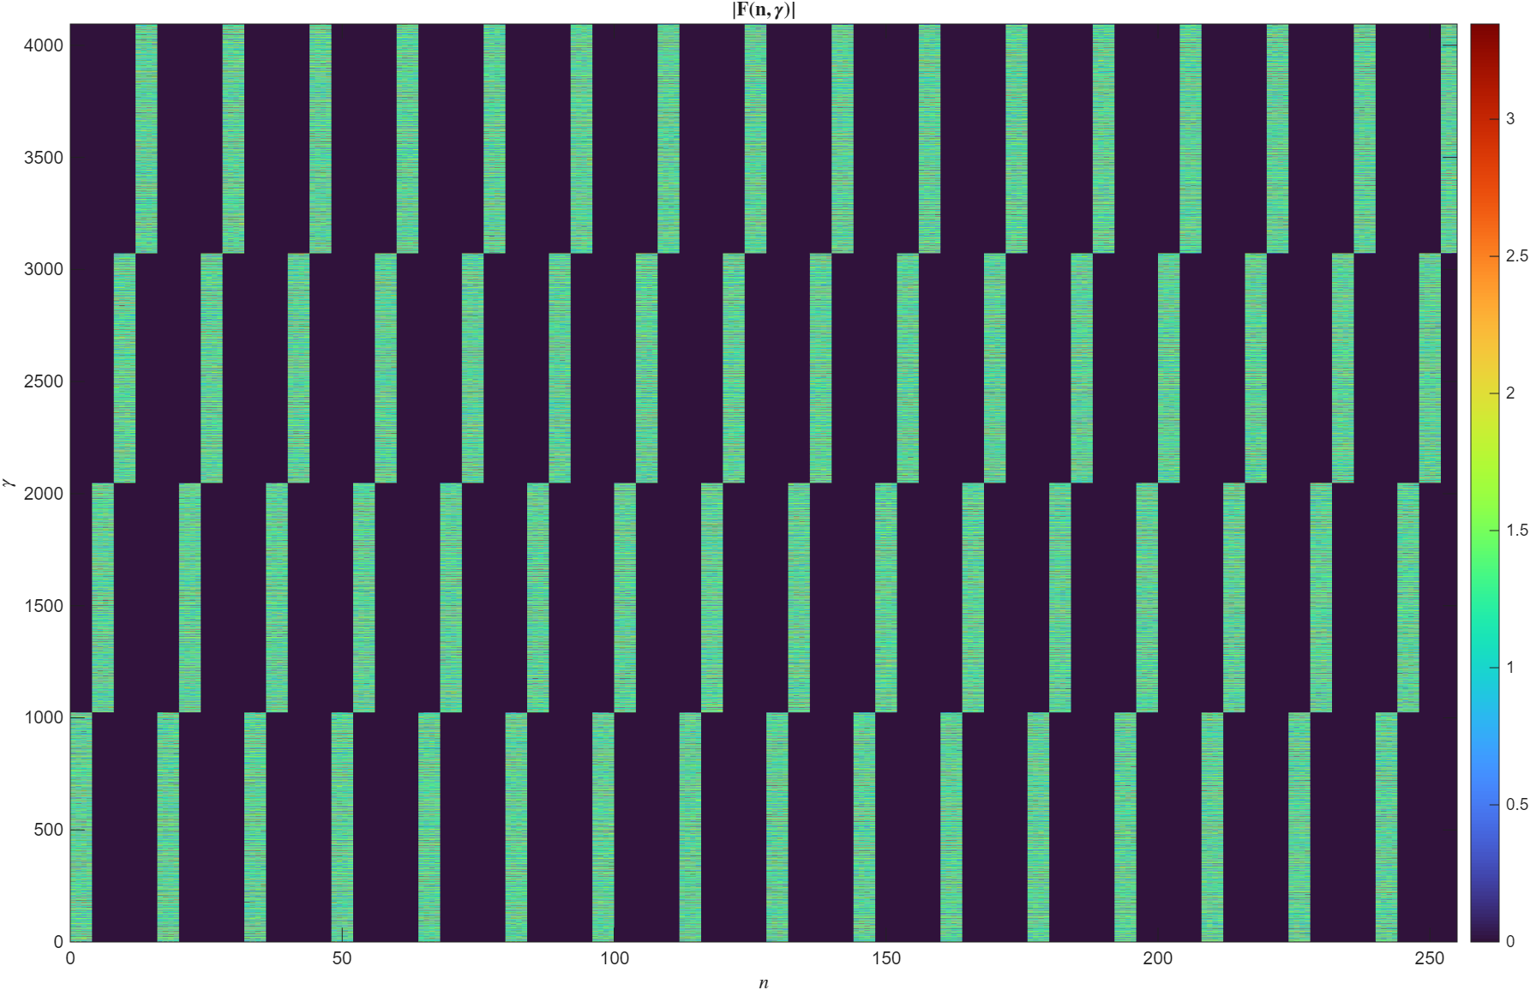
Figure 3 Fixed/deterministic frequency hopping scheme across OFDM symbols
The simulation setup utilizes a time-frequency grid consisting of 4096 subcarriers and 300 OFDM symbols. While the instantaneous bandwidth allocated to a single UE is limited to a block of 1024 subcarriers, the frequency hopping mechanism shown in Figure 3 enables the UE to span the entire frequency range of 4096 subcarriers over the transmission period. This strategy significantly enhances delay sensing resolution by increasing the effective bandwidth without requiring additional instantaneous subcarrier allocation.
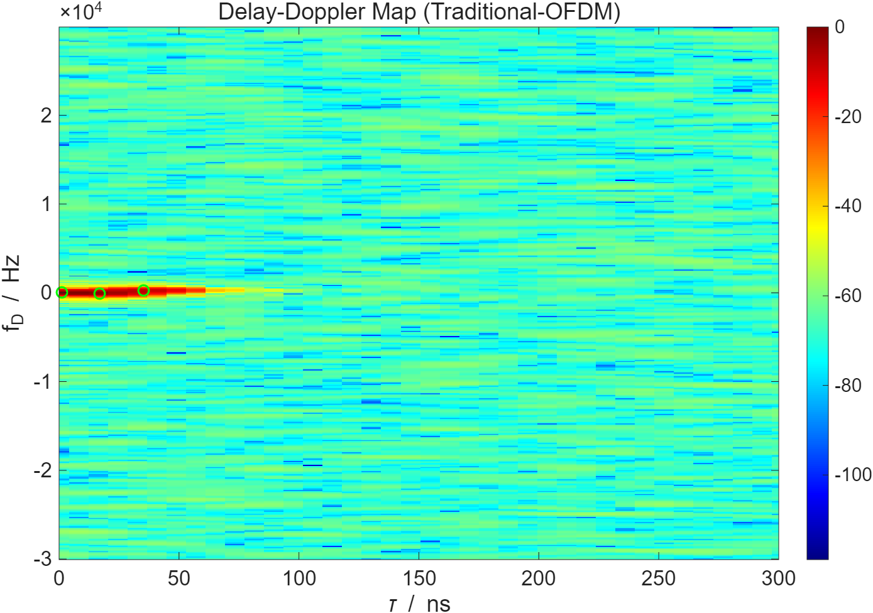
(a) Delay-Doppler map of Traditional OFDM
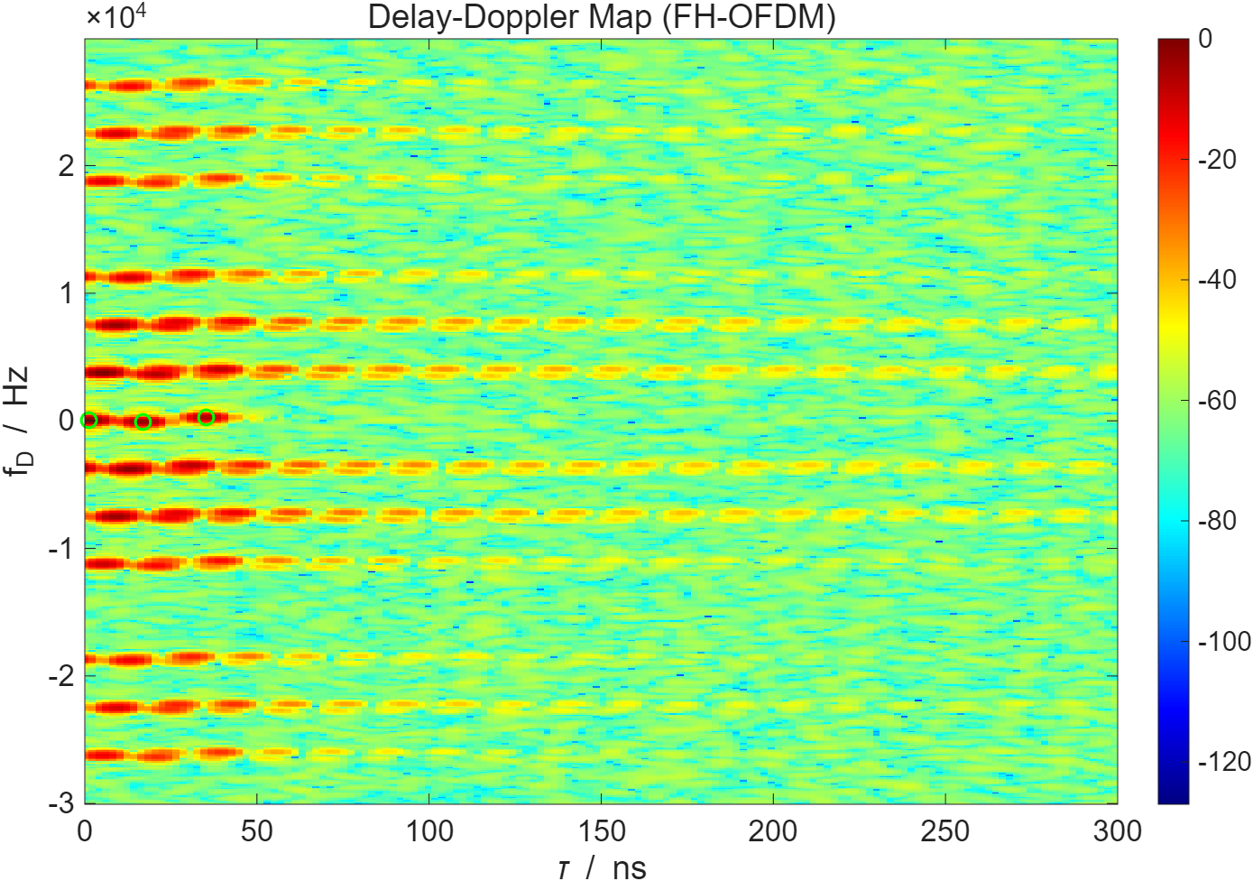
(b) Delay-Doppler map of FH-OFDM
Figure 4 Comparison of Delay-Doppler maps between Traditional OFDM and FH-OFDM waveforms, with green circles indicating the ground truth positions of three targets. In the above simulation, three targets are configured with ground truth parameters of , , and . As illustrated in Figure 4, the frequency-hopping mechanism significantly enhances the delay resolution. By spanning a wider effective bandwidth over the transmission period, the FH-OFDM waveform yields a much sharper main lobe along the delay axis compared to traditional OFDM. However, this improvement comes with a trade-off: the discontinuous frequency allocation introduces periodic grating lobes in the Doppler domain, which consequently decreases the maximum unambiguous Doppler range. Despite this limitation, these artifacts can be effectively managed. Advanced signal processing techniques, such as compressed sensing, can be leveraged to suppress these grating lobes and resolve the true targets by exploiting the sparsity of the sensing channel.

Conclusions
In this contribution, we provide the following proposals.
Proposal 1: Spectrum extension has the capability to reduce PAPR. Building upon this foundation, the expanded scope of spectrum extension application can be considered for reducing PAPR.
Proposal 2: Extending the waveform to enable controlled spectrum spreading should be considered, with the option of overlapping resources among multiple users. In addition, alternative spectrum extension schemes beyond the currently defined extension factors should be explored. Such approaches can enhance sensing resolution while maintaining low PAPR and preserving coverage performance.
Proposal 3: Extending the waveform to enable controlled spectrum spreading should be considered, with the option of overlapping resources among multiple users. In addition, alternative spectrum extension schemes beyond the currently defined extension factors should be explored. Such approaches can enhance sensing resolution while maintaining low PAPR and preserving coverage performance.

References
- Chairman’s notes for 3GPP TSG RAN WG1 Meeting 122, Bengaluru, India, Aug 25th – 29th, 2025

